Ramone Martin
ISTA 322
12.10.25

NBA statistics 2015-2016

Data:
The two data sources used are as follows:

Github: https://github.com/mvanbommel/scrape_nba_box_scores/blob/master/2015_2016_NBA_box_score_player_data.csv
This dataset is a game by game dataset with over 31,000 rows that has game stats for every NBA player during the 2015-2016 NBA season. This source has only in-game statistics, team affiliations, and other in-game stats such as home and away teams and if the team won or lost. I used the statistical portion of the dataset, so only quantitative data that could be combined and averaged out to show overall season averages. I used the player name as well as a unique identifier. The challenges cleaning this dataset were that it was extremely large to deal with. There were only 475 unique values in the name column so I had to combine like names to average stats, then had to drop duplicates and manually change name values from players that had similar names. I had to change the datatype of some columns in order to have them aggregate properly or load into SQL properly as well.

BallDontLie API - https://docs.balldontlie.io/#get-a-specific-player

This dataset was an API that contains information on every NBA player since 1946. This dataset contained over 5000 rows and contained many duplicates, as well as the same players with like names as well. I had to manually create a Player column from the name columns to match the github dataset. This dataset contained information such as year drafted, country of origin, height, weight, and other non game related statistics. I used the player name and then used niche columns that would be interesting to see after querying such as jersey number, height, draft position, and college affiliation as well. The challenges cleaning this dataset were similar to the other dataset, there were lots of nefarious rows that had to be removed as well as unnecessary columns. I had to change the datatype of some columns in order to have them aggregate properly or load into SQL properly as well.

RDB Schema :
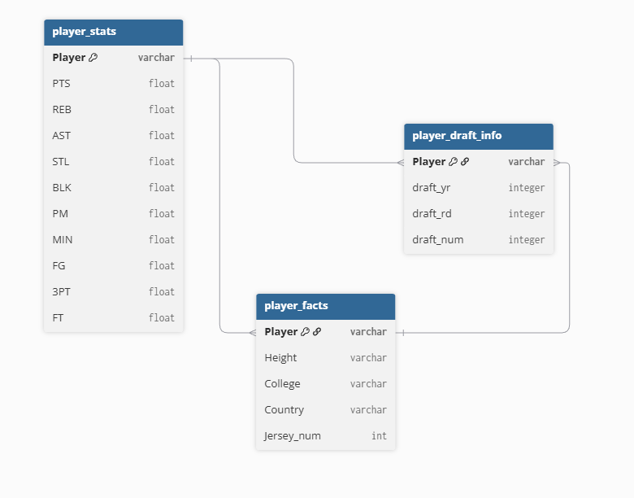

Queries:
I ran 5 test queries.

1) Top 10 players in PTS who went to UCLA
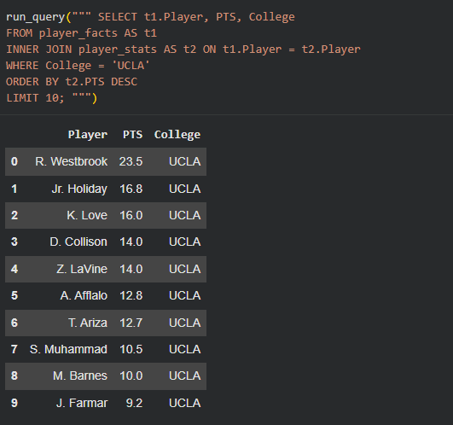

2) Top 10 players in Rebounds who are 6'3

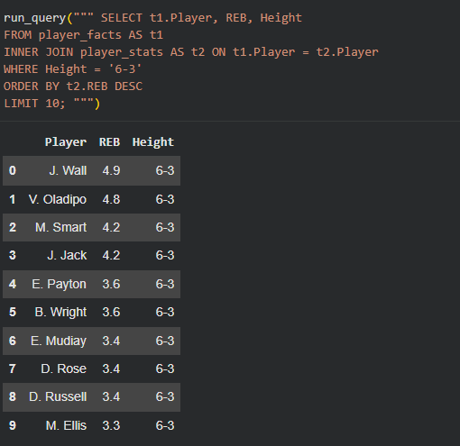

3) Top 10 players in PTS drafted 1st overall

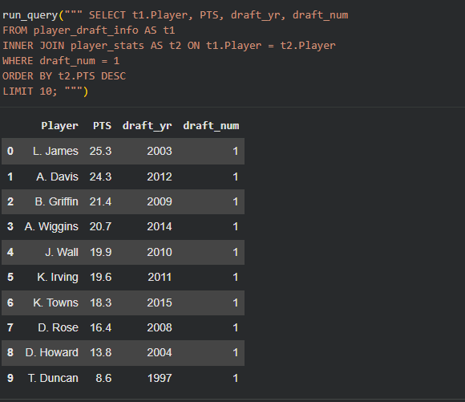

4) Top 10 players in PTS from the USA

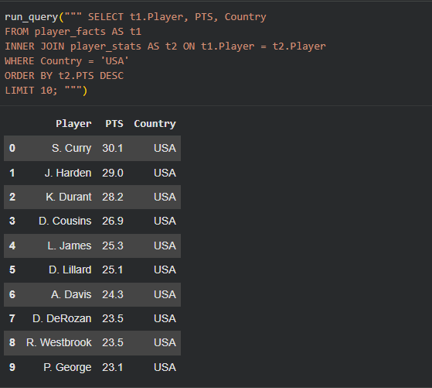

5) Top 10 players in PTS with the jersey number 23

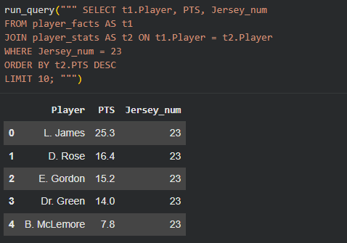

Plots:
I created two plots.
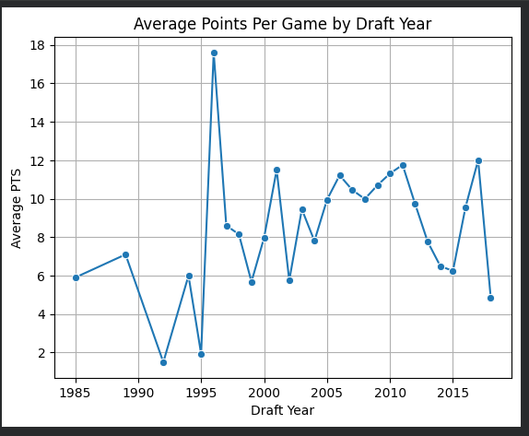
1) A plot showing the average scoring for players drafted by year drafted

2) PPG avg by country for the top 10 scoring countries

